Lab 5 Reflection

Proof
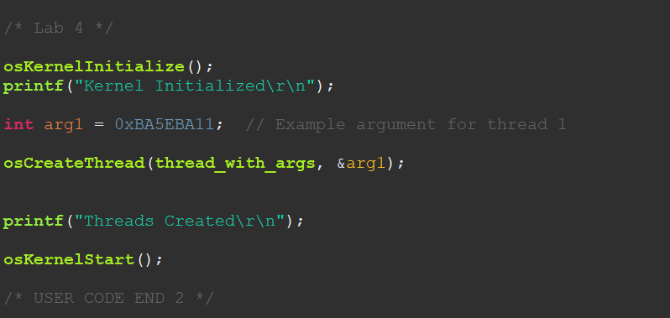
PT1: Calling the thread function with args
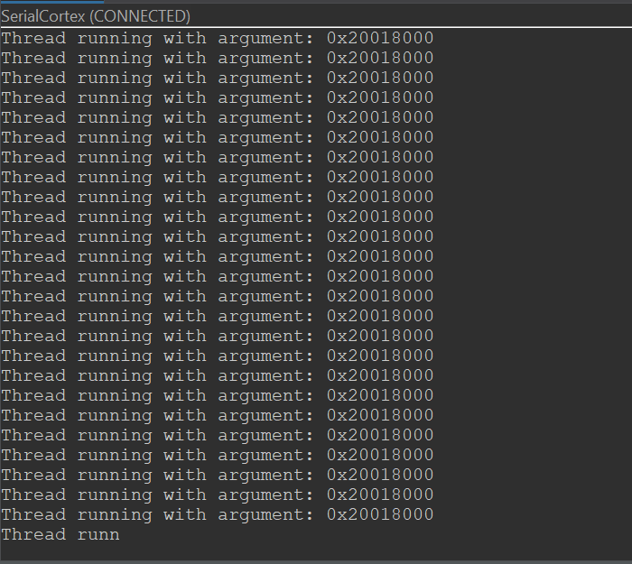
PT1: Output
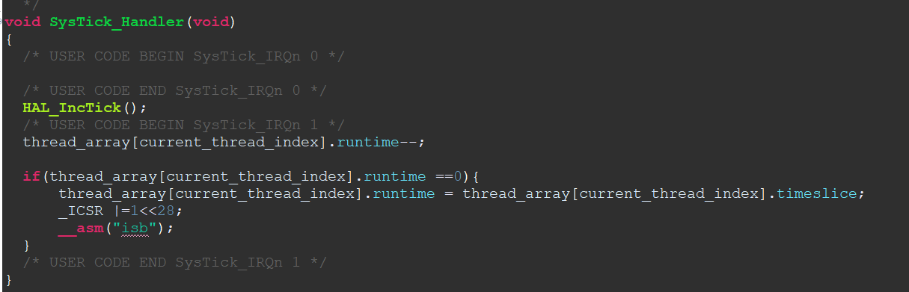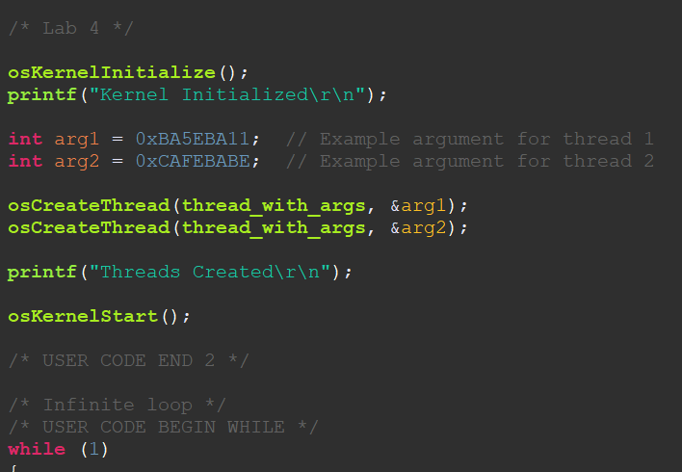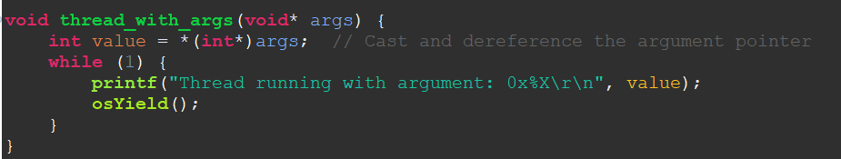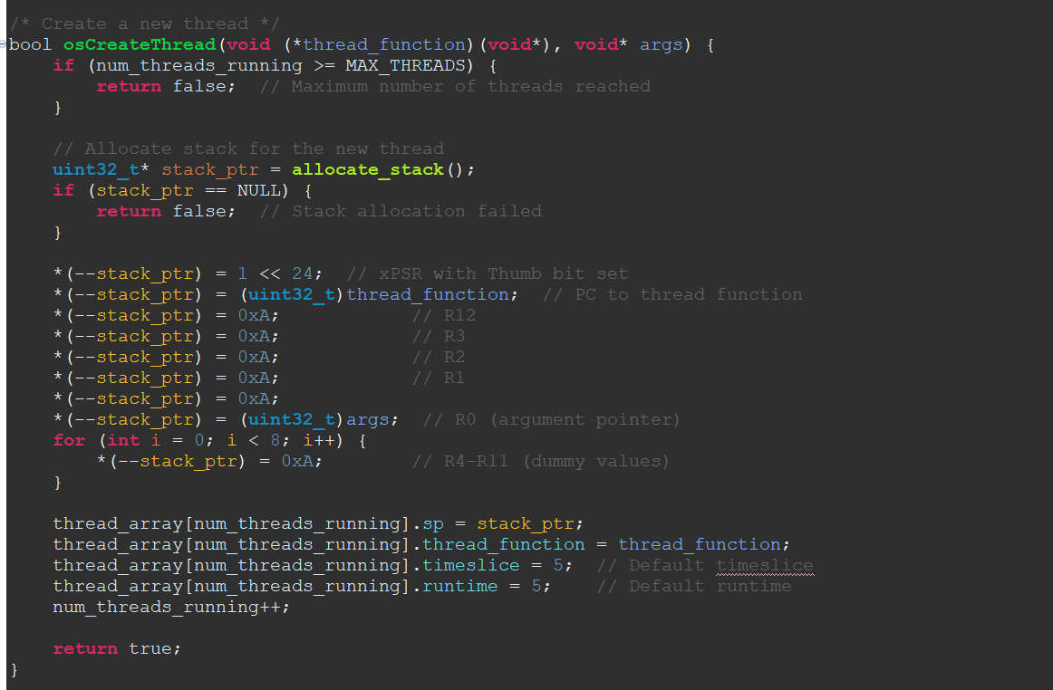
Function Definitions

Question 1
Explain the process by which an argument gets passed into a thread. Begin with what the user has to do, then talk about what the OS has to do, and finally explain why it works.

Answer:
1. User's Role:
- Define the Thread Function: The user writes a function the thread will execute. This function typically accepts a single void* parameter, allowing flexibility in passing various data types.
void threadFunction(void* args) {
// Thread code utilizing 'args'
}
- Prepare the Argument: The user prepares the data to be passed to the thread by allocating and initializing a structure or variable.
struct ThreadArgs {
int value;
// Other fields as needed
};

struct ThreadArgs* args = malloc(sizeof(struct ThreadArgs));
args->value = 42;
- Create the Thread: The user invokes the OS's thread creation function, passing the thread function and the argument.
osCreateThread(threadFunction, (void*)args);
2. Operating System's Role:
- Allocate Stack Space: The OS allocates stack memory for the new thread.
- Initialize the Stack Frame: The OS sets up the initial stack frame for the thread, adhering to the ARM Procedure Call Standard (AAPCS). This involves:
  - xPSR: Setting the Program Status Register with the Thumb state bit.
  - PC: Assigning the Program Counter to point to the thread function.
  - LR: Setting the Link Register to a known value (e.g., 0xFFFFFFFD) to handle thread exit.
  - R0: Placing the argument pointer in register R0, as per AAPCS, which specifies that the first argument is passed in R0.
  - R1-R3, R12: Initializing other registers to default values.
  - R4-R11: Setting callee-saved registers to default values.
This setup ensures that when the thread starts, it retrieves the argument from R0.
3. Why It Works:
The ARM Cortex-M4 architecture follows the ARM Procedure Call Standard (AAPCS), which defines how functions receive parameters and return values. According to AAPCS:
- Register Usage: The first four arguments to a function are passed in registers R0 to R3.
- Stack Usage: If there are more than four arguments, the additional ones are passed on the stack.
By placing the argument pointer in R0 during thread initialization, the OS ensures that the thread function receives the correct parameter upon execution. This convention allows seamless function calls and thread executions, as both the compiler and the OS adhere to the same calling conventions.

Question 2
Why can’t you call osYield in any of our context-switching functions (PendSV_Handler, SVC_Handler and its associated SVC_Handler_Main, and SysTick_Handler)? What happens if you do, and why is it bad?

Answer:
Invoking osYield within the context-switching functions—namely PendSV_Handler, SVC_Handler (and its associated SVC_Handler_Main), and SysTick_Handler—is problematic and should be avoided. Here's why:
1. Re-entrancy Issues: These handlers are part of the kernel's core interrupt service routines (ISRs). Calling osYield within them can lead to re-entrancy problems, where the function is invoked again before the previous execution has been completed. This can corrupt the kernel's state and lead to unpredictable behaviour.
2. Stack Overflow Risks: Each interrupt handler operates on a limited stack space. Invoking osYield within these handlers can cause additional function calls and context switches, consuming more stack space. This increases the risk of stack overflow, which can crash the system.
3. Nested Interrupts and Priority Inversion: Calling osYield within an ISR can lead to nested interrupts, where a lower-priority interrupt preempts a higher-priority one. This can cause priority inversion, where lower-priority ones, degrading system performance, delay high-priority tasks.
4. Kernel State Corruption: The kernel relies on a well-defined sequence of operations during context switching. Introducing osYield within these handlers can disrupt this sequence, leading to kernel state corruption and system instability.
Conclusion: To maintain system stability and ensure predictable behavior, osYield should not be called within PendSV_Handler, SVC_Handler, SVC_Handler_Main, or SysTick_Handler. These handlers are designed to manage context switching and system ticks without additional intervention. Invoking osYield within them can lead to reentrancy issues, stack overflows, nested interrupts, and kernel state corruption, all detrimental to the system's operation.

Question 3
In this lab we set up the fundamental OS clock to be 1ms. Say we wanted it to be 0.1ms instead. Discuss the benefits and downsides of doing this.

Answer:
Adjusting the operating system's tick rate from 1 ms to 0.1 ms involves several trade-offs:
Benefits:
- Improved Responsiveness: A higher tick rate allows the OS to handle time-sensitive tasks more promptly, reducing latency for operations that require rapid attention.
- Finer Time Granularity: With a 0.1 ms tick rate, the system can measure and manage time intervals with greater precision, which is beneficial for applications needing high-resolution timing.
Downsides:
- Increased CPU Overhead: A higher tick rate means the CPU processes more timer interrupts per second, leading to increased overhead. This can reduce the CPU time available for executing application code.
- Higher Power Consumption: More frequent interrupts prevent the CPU from entering low-power states as often, resulting in increased power consumption—a critical consideration for battery-powered or energy-sensitive devices.
- Potential for System Instability: If the system cannot handle the increased interrupt load efficiently, it may lead to missed deadlines or system instability.
In summary, while a 0.1 ms tick rate can enhance system responsiveness and timing precision, it also introduces significant overhead and power consumption challenges. Therefore, it's essential to balance the need for finer timing resolution against the system's capacity to manage the associated overhead.

Question 4
Explain the difference between co-operative and pre-emptive multitasking from the user perspective and in terms of what the OS has to do for each one.

Answer:
Multitasking allows an operating system (OS) to execute multiple tasks or processes seemingly simultaneously. The two primary approaches to multitasking are cooperative and preemptive, each differing in how control is managed between the OS and running processes.
Cooperative Multitasking:
From the User's Perspective: In cooperative multitasking, applications are responsible for yielding control to allow other processes to run. If an application fails to yield, it can monopolize the CPU, leading to system unresponsiveness. Users may experience system hangs if a single application becomes unresponsive.
From the OS's Perspective: The OS relies on each process to voluntarily yield control, either when idle or at predefined points. The OS does not forcibly interrupt processes; instead, it waits for them to release control. This approach simplifies the OS design but can lead to stability issues if applications do not behave cooperatively.
Preemptive Multitasking:
From the User's Perspective: Preemptive multitasking provides a more responsive and stable system. The OS can interrupt and switch between applications, ensuring that no single process can monopolize the CPU. Users experience smoother multitasking and reduced risk of system hangs due to unresponsive applications.
From the OS's Perspective: The OS has greater control, as it can preempt (interrupt) running processes to allocate CPU time to others. This requires a more complex scheduler to manage context switching and process priorities effectively. While it enhances system stability and responsiveness, it also demands more from the OS in terms of resource management and scheduling algorithms.
In summary, cooperative multitasking depends on well-behaved applications to share CPU time, which can lead to issues if they do not yield control appropriately. Preemptive multitasking, however, empowers the OS to manage CPU time allocation, leading to a more stable and responsive user experience.

Question 5
The final exercise of this lab had you mix together yielding and time-based pre-emptive context switching. How is it possible for these two mechanisms to work together?

Answer:

In this lab, I implemented both cooperative and preemptive multitasking mechanisms, allowing threads to yield control voluntarily and to be preempted by the operating system based on time slices. These two mechanisms can coexist and function together effectively due to their complementary nature.
Cooperative Multitasking (Yielding): In cooperative multitasking, a thread voluntarily relinquishes control of the CPU by calling a function like osYield(). This explicit yield indicates that the thread is ready to allow other threads to execute. The operating system then performs a context switch to another ready thread. This approach relies on the threads' cooperation to ensure fair CPU sharing.
Preemptive Multitasking (Time-Based): In preemptive multitasking, the operating system enforces context switches based on a timer interrupt, such as the SysTick timer configured to trigger at regular intervals (e.g., every 1 ms). When the timer interrupt occurs, the OS checks if the currently running thread has exhausted its allocated time slice. If so, it preempts the thread and switches to another ready thread, ensuring that no single thread can monopolize the CPU.
Integration of Both Mechanisms: By combining both yielding and time-based preemption, the system benefits from the advantages of each approach:
- Responsiveness: Threads that can determine appropriate points to yield (e.g., after completing a task or reaching a logical checkpoint) can call osYield(), allowing for efficient CPU utilization and responsiveness to other threads' needs.
- Fairness: The preemptive mechanism ensures that even if a thread does not yield voluntarily, it will be preempted after its time slice expires, preventing any single thread from monopolizing the CPU.
The SysTick timer interrupt (SysTick_Handler) decrements the runtime of the current thread. If runtime reaches zero, it triggers a PendSV interrupt to perform a context switch. Simultaneously, threads can call osYield() to voluntarily trigger a context switch before their time slice expires. This dual mechanism ensures that the system remains responsive and fair, accommodating both cooperative and preemptive multitasking paradigms.
By integrating these two mechanisms, the operating system can handle a wide range of thread behaviors, from those that yield control cooperatively to those that require enforced preemption, resulting in a robust and efficient multitasking environment.

Grading
Each question is evaluated based on the following scale.
Meets expectations: The answer is entirely correct. The answer is sufficiently detailed to include the major ideas necessary to prove that the student understands the concept. The answer is clear.
Approaching expectations: The answer contains no incorrect statements, but requires more detail or is too vague to convince the grader that the student understands the concept. The answer is clear.
Does not meet expectations: The answer either contains some incorrect statements or lacks detail to the degree that major portions of the question are left unanswered. The answer is not clear.
Not observed: the answer is largely incorrect or absent.
To get a grade for a question, you must obtain a rating of “meets expectations” on that question. You may resubmit as many times you like until you achieve that rating.

